2D-Platformer
Software Architecture Document

Version <1.2>

Revision History

Date | Version | Description | Author
07.10.2018 | 1.0 | Initial Document | Marc Ackermann
07.10.2018 | 1.1 | Class- and Component diagrams | Dennis Appel
02.11.2018 | 1.2 | Rework critical diagrams | Dennis Appel, Marc Ackermann

Table of Contents
1. Introduction 6
1.1 Purpose 6
1.2 Scope 6
1.3 Definitions, Acronyms, and Abbreviations 6
1.4 References 6
2. Architectural Representation 6
3. Architectural Goals and Constraints 7
3.1 Unity Lifecycle 8
3.1.1 Visual Representation 8
3.1.2 Description 9
4. Class View 10
4.1 Architectural Concepts 10
4.2 Class Diagram 10
4.3 Unity-based Interaction 11
4.4 Short Description of Architecturally Significant Classes 11
4.4.1 GameManager 11
4.4.2 AudioManager 11
4.4.3 PlayerController 11
4.4.4 SkillManager 11
4.4.5 EnemyController 11
4.4.6 PuzzleController 11
4.4.7 ChestInteraction 11
5. Use-Case Realizations 12
5.1 Combat 12
5.2 Boss Fight 13
5.3 Item Interaction 14
5.4 Puzzle Object Interaction 15
5.5 Music Skill 16
6. Component View 17
6.1 Component Diagram 17
6.2 Short Description of the components 18
6.2.1 GameManager 18
6.2.2 MenuController 18
6.2.3 SettingManager 18
6.2.4 ChallengeModeManager 18
6.2.5 LevelGenerator 18
6.2.6 MusicLibrary 18
6.2.7 LevelSpecificControllers 18
6.2.8 PlayerCharacter 18
6.2.9 EnemyController 18
6.2.10 SkillManager 18
7. Package View 19
8. Deployment View 19
8.1 Deployment Diagram 19
8.2 Short Description of the nodes 19
9. Design of significant Classes 20
9.1 Enemy 20
9.2 Player 21
9.3 Global Managers 22
9.4 ChestInteraction 23
9.5 MenuController 23
9.6 Puzzle 23
10. State Diagrams 24
10.1 AudioSource 24
10.1.1 Description 24
10.2 SkillManager 24
10.2.1 Description 24
10.3 Skills 24
10.3.1 Description 24
10.4 Chest 24
10.4.1 Description 24
10.5 PlayerController 25
10.5.1 Description 25
10.6 EnemyController 25
10.6.1 Description 25
10.7 PuzzleController 25
10.7.1 Description 25
10.8 GameManager 26
10.8.1 Description 26

Software Architecture Document

Introduction

Purpose

This document provides a comprehensive architectural overview of the PuzzleTrainer system, using several different architectural views to depict different aspects of the system. It is intended to capture and convey the significant architectural decisions which have been made on the system.

Scope

This Software Architecture Document applies to the 2D-Platformer System which will be developed by THM Friedberg.

Definitions, Acronyms, and Abbreviations

See the Glossary [3].

References

Applicable references are:
[1] Vision
[2] Glossary
[3] Software Requirements Specification

Architectural Representation

This document presents the architectural as a series of views.
These views are presented as Software Architect or Enterprise Architect Models and use the Unified Modelling Language (UML 2.0).

Architectural Goals and Constraints

The game must be platform independent and portable.
The game shall be implemented into the Unity Engine using C#.
Due to the usage of Unity, the software architecture must follow the unity given constraints. That means that every entity is to be a game object, which is given several scripts that use the Unity API to manipulate said object.
The scripts must follow the Unity defined process, as such most code execution is bound to the Unity lifecycle.

The software development process shall be compliant to the Rational Unified Process (RUP).

Unity Lifecycle

Visual Representation
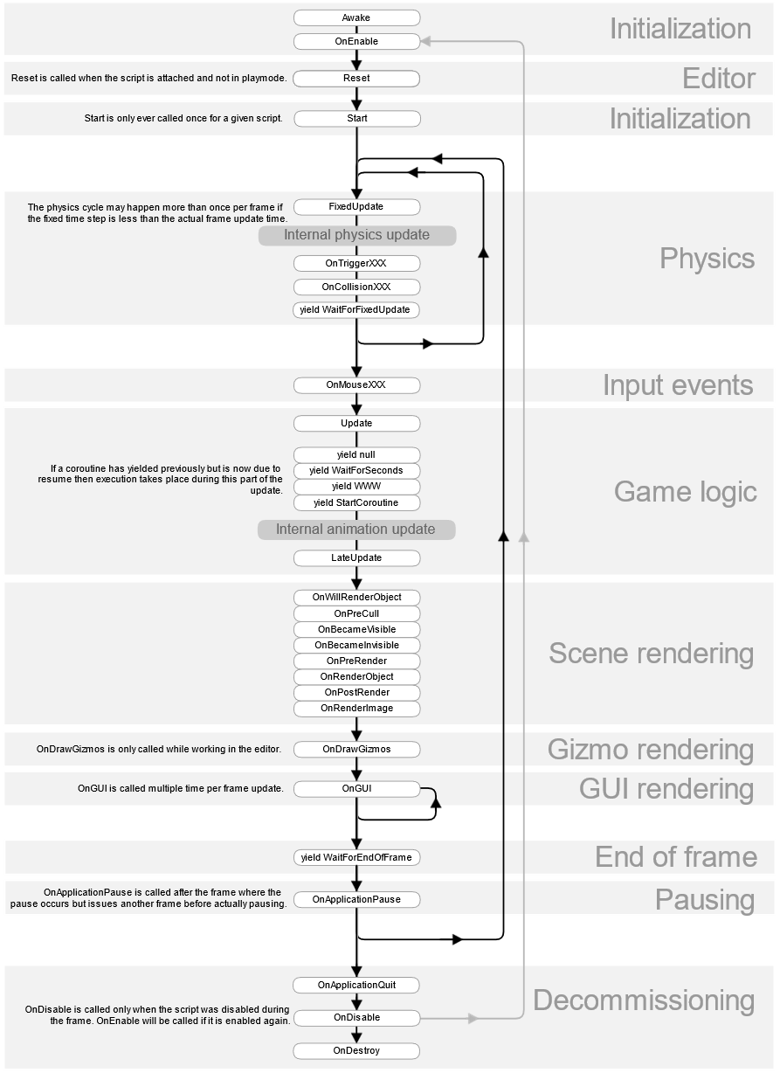

Description
The Unity Lifecycle can be split into three parts: initialization, active and decommissioning.
In the initialization phase scripts can initialize their variables, find references etc. The most important Unity provided methods in that phase are Awake() and Start(), they are comparable to constructors, however they don’t allow usage of parameters. Awake() and Start() can both be used to initialize values, the difference is however, that Awake() gets called before Unity enables the game object, while Start() is called after. Most of the time Start() will be used to initialize the script, however in situations where you want to reference an instance of the class as a static member within the same class, singleton pattern, it is recommended to use Awake() instead, as Start() can be used later to start code execution.
A good example for that is the Audio System. You want to be able to access the Audio System from a lot of classes so using the singleton pattern here is beneficial. You also want the Audio System to start Playing the theme as soon as the level is loaded. As a result you would initialize the Audio Managers static member in Awake() and then start playing the theme in Start().

The active phase can be split into multiple parts as well. The physics and the game logic part. For the game to function properly both parts are equally important.
To understand them individually you first must understand how the entire active phase works. The active phase is repeated on every new frame, depending on your system it may be 60 times a second, while for others this would be 140 times a second. However, the physics part of the active phase is using an independent timer. This results in inconsistencies between iterations, e.g. the physics iteration may happen more than one time during a frame, or it may not happen at all. What this means is, that you want to split your scripts logic into physics logic and game logic to make sure everything works the best way possible.
Looking at the Lifecycle Unity captures input events right before calling the Update() method. The Update() method, as described above, is part of the game logic cycle and thus called once every frame. As a consequence the Update() method is used to work with input events. For Example, the player wants to move his character to the left and presses the key “A” to do so. Unity captures this as an OnKeyDown() event which than can be used in the Update() method to initiate player movement. If it was used in FixedUpdate() inputs could be missed.
The Problem now is that initiating player movement within the update method causes inconsistencies, the character may be faster on some systems than on others. Since movement is a physics operation it must be handled within the FixedUpdate() method. The solution is to store the players input in a class variable which is then accessed by FixedUpdate() on every physics cycle. As a result, the game captures inputs as soon as possible, while using the internal physics engine to translate the captured inputs into movement.
In short, any event that requires an immediate reaction, such as range detection, collision handling, input handling, etc., should be handled within the Update() method, while the results that require physics interactions, such as movement, jumping, etc., will be stored in a variable that will be used within the FixedUpdate() method.
While the active phase offers a lot more functionality than Update() and FixedUpdate(), most of it is irrelevant for our game.

The decommissioning phase is comparable to destructors. It allows to trigger events if e.g. an opponent was beaten and its game object is about to be destroyed.

Class View

Architectural Concepts
The game adheres the Unity design standards, thus using several scripts per entity, with an entity being defined as a game object.
Therefore, the following UML diagrams are to be a translation to common UML standards, rather than as is.

Class Diagram

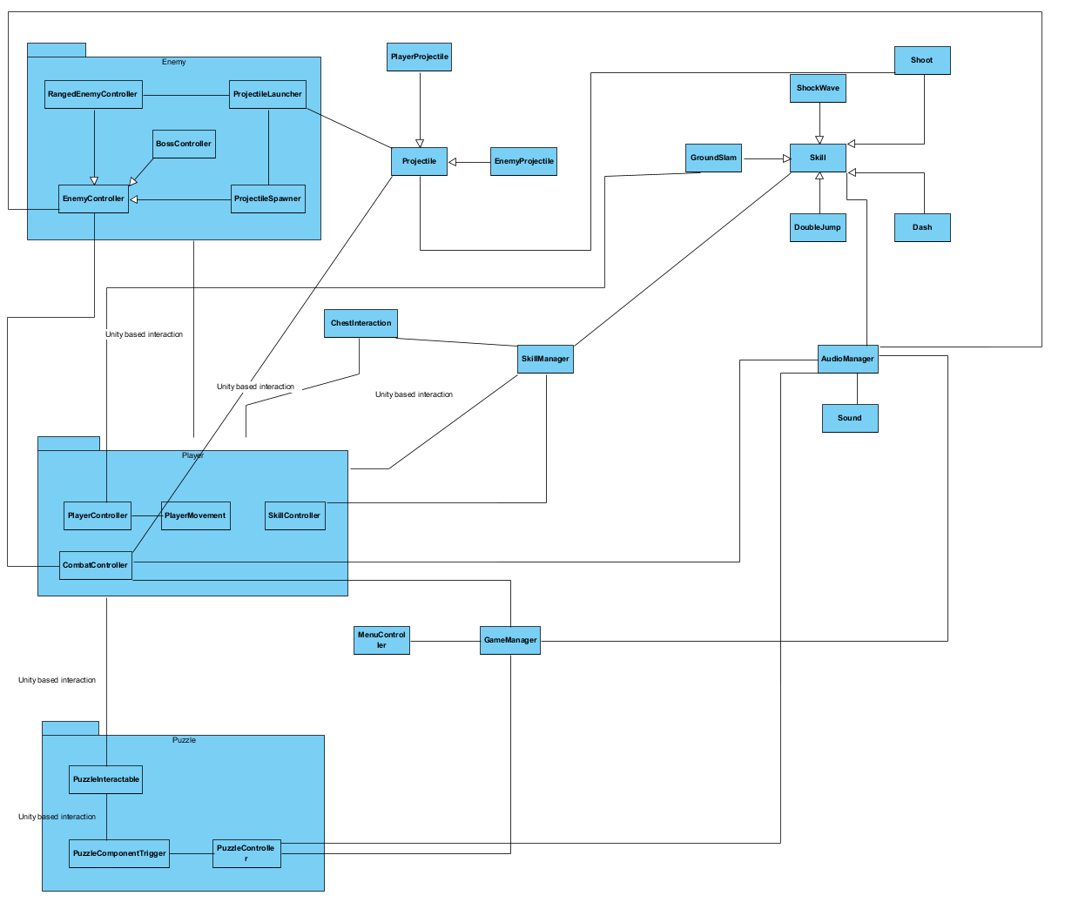

Unity-based Interaction
Some associations between classes are marked as unity-based interactions. These describe an indirect relationship between classes or objects. To showcase the use of objects, classes that are bound to a single object are put into a pseudo package.
The Interaction between ChestInteraction and the Player is unity based, meaning that while it is an interaction between the player object and the chest object, the classes never communicate directly with each other. If the player object is in range of the chest that has the ChestInteraction script, the ChestInteraction will show a prompt and upon a key press the player can use a new skill. There is no direct communication between said classes however.

Short Description of Architecturally Significant Classes

GameManager
The GameManager tracks the current state of the game. It allows for pausing, as well as states such as Game Over.

AudioManager
The AudioManager is used to play sounds in the game. E.G. if the player jumps, the AudioManager is told to play the jumping sound.
The AudioManager can handle all required sound effects simultaneously.

PlayerController
The PlayerController is responsible for moving the player object. However, it does not handle player inputs, instead it has a method Move(), which manipulates the player object and is called from a script that only handles inputs.

SkillManager
The SkillManager tracks the Skills available to the player. It works together with a Controller class, which handles the skill usage, to return the currently equipped skill for usage. It also handles changing of skills.

EnemyController
The EnemyController checks if the player object is in range and allows an enemy object to follow and attack the player object if it is in range.

PuzzleController
The PuzzleController unlocks new areas upon completion of its assigned puzzle by the player. It tracks the state of its components and destroys barriers if necessary.

ChestInteraction
The ChestInteraction is used to grant the player new skills to use. As such it works closely with the SkillManager.

Use-Case Realizations
The following sequence diagrams describe specific in game situations.
The found messages are unity events handled within the corresponding class, e.g. unity sends an onCollisionEnter2D() event which the EnemyController handles.

Combat
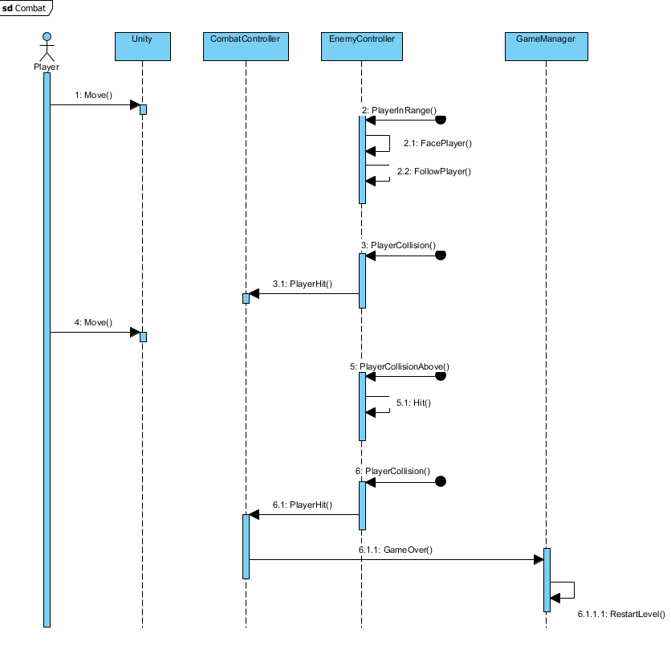
The diagram describes a combat interaction between an enemy and the player in which the player eventually dies.
The player object is moved by Unity, thus unity is notified when and where to move the player object. If the player object gets in range of the enemy object, the EnemyController recognizes it by asking unity if an object with the player tag is within a certain radius. The EnemyController then rotates and moves the enemy object towards the player object. If it detects a collision with the player object, it then notifies the CombatController of the player object that it was hit.
The player again starts moving, this time the player is jumping on top of the enemy, thus the EnemyController detects a collision from above and notifies itself it was hit.
The enemy object then collides with the player again, notifies its CombatController which notifies the GameManager that the player was hit too often and its Game Over. The GameManager finally restarts the level.

Boss Fight
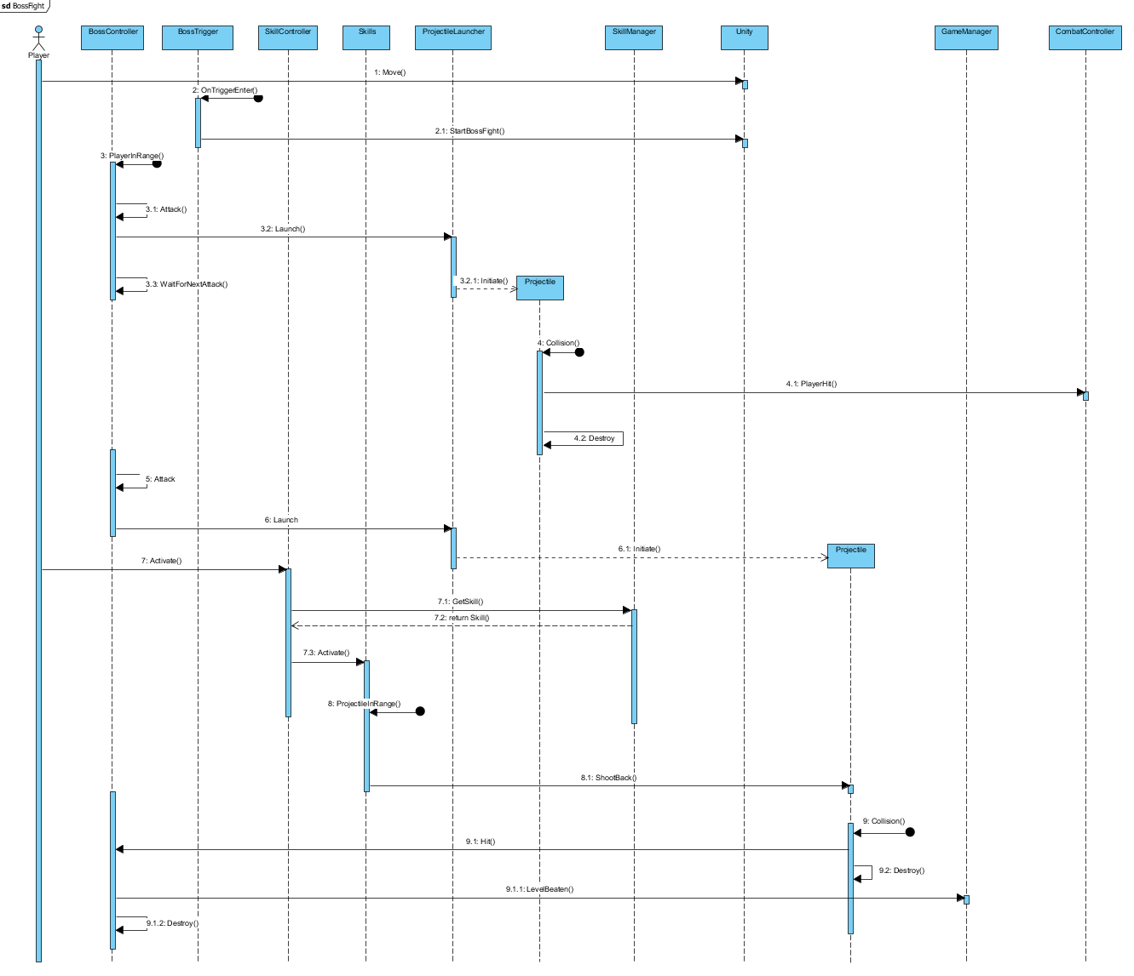

The player object is moved towards a trigger. The trigger gets notified that something has entered its detection area, thus starting the boss encounter.
The boss fight generally follows the same process as the Combat. It detects whether a player is in range or not and starts attacking, however besides using collision the boss is able to shoot projectiles.
So instead of just following the player object, the BossController notifies its ProjectileLauncher class to start spawning Projectiles. If the projectile collides with the player object, it notifies its combat controller about the collision and destroys itself.
Meanwhile the BossController is in a waiting state which lasts until it can fire another projectile.
This time the projectile does not hit the player. Instead the player activates a skill using the SkillController class. The SkillController requests the current equipped skill from the SkillManager and activates it. The Skill class detects that the projectile object is in range and calls its ShootBack() method to move it back towards the boss object. The projectile then detects a collision with the boss object, telling its BossController it was hit and destroying itself.
The BossController notifies the GameManager it was beaten and destroys itself.

Item Interaction
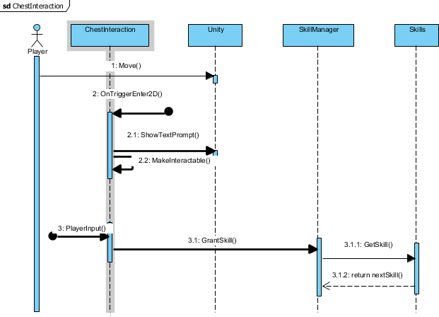
The player object is moved towards a chest. The chest is notified that the player object has entered its detection radius. It then notifies Unity to show a prompt on the screen and becomes interactable.
If it detects an Input such as a key press, it tells the SkillManager to set the Skill with its defined skill id as active. The Skill Manager then looks for the specific skill and stores it as a variable.

Puzzle Object Interaction

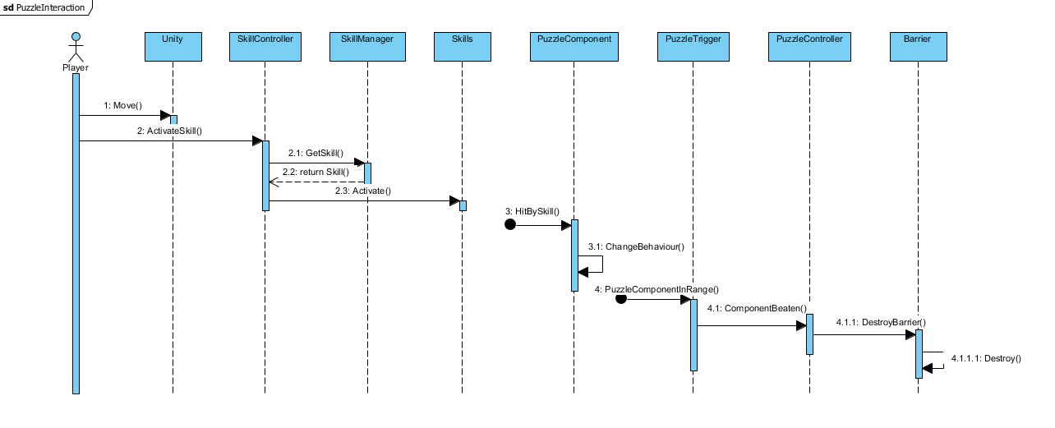
The player moves towards a PuzzleComponent and activates a skill, the skill activation follows the same sequence as described in the Boss Fight diagram).
A PuzzleComponent detects a collision with an object created by the used skill and changes its behaviour, e.g. it enters the Unity physics calculation and becomes movable.
If the PuzzleComponent enters the range of a PuzzleTrigger, the PuzzleTrigger notifies the PuzzleController that the Component was beaten, or solved, the PuzzleController then destroys a barrier blocking the path.

Music Skill
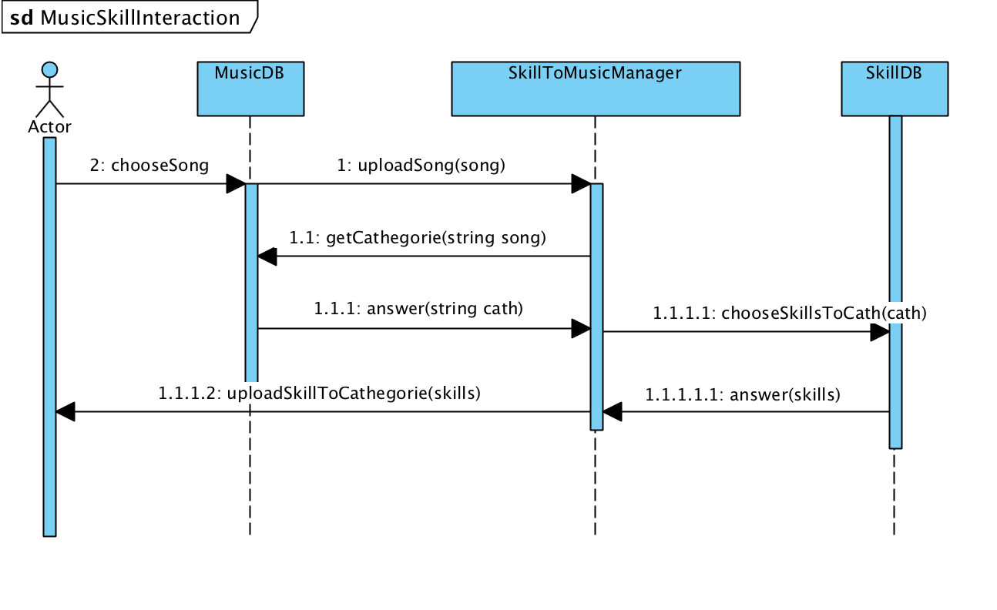

Component View

Component Diagram
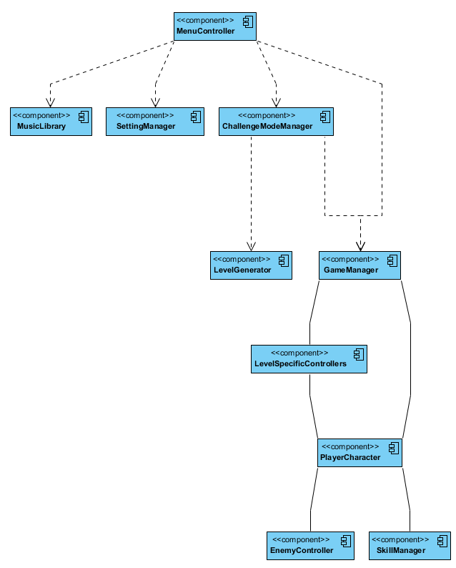

Short Description of the components

GameManager
This component realizes the management of the game, such as ending, pausing and reloading the level.

MenuController
This component starts a new level or ends the application.

SettingManager
This component uses the Unity API to change graphic and volume settings.

ChallengeModeManager
This component manages the creation and loading of challenge mode levels.
It requires the LevelGenerator and the MusicLibrary.

LevelGenerator
This component generates new levels by either using a predefined seed, or a local music track that has been added to the MusicLibrary.

MusicLibrary
This component allows adding and removal of local music files to the game, to be used for the Challenge Mode.

LevelSpecificControllers
This contains controllers such as custom PuzzleControllers that control the player interaction with puzzle segments, such as boss fights or general puzzles found in the level.

PlayerCharacter
This component controls the player character, allows movement and skill usage, and world interaction.

EnemyController
This component manages combat between player and NPC, it also deletes defeated entities.

SkillManager
This component allows the use and management of skills by the player.

Package View

Due to the usage of Unity, there are no packages.

Deployment View

Deployment Diagram

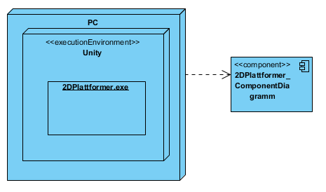

Short Description of the nodes
The PC represents a standard Windows PC with an Intel Core Duo E5200 and a GeForce 9800GTX+ (1GB) or better.

The execution environment for the 2DPlattformer.exe consists of Unity.

Design of significant Classes
The following diagrams describe significant classes.
While many have a lot of attributes, most don’t offer more than one or two public methods. This is due to Unity. Most of the class’s logic is handled within the unity lifecycle and thus not available outside the class.
Notable exceptions are the Projectile and its derived PlayerProjectile class. As described 3.1.2 Start() is a unity method used for object initialization, while it is usually private it can be defined as protected and virtual, thus allows for overriding in deriving classes. The PlayerProjectile is different in that way, that the players speed is higher than the one of enemies. This could cause the player object to collide with its own projectiles. To eliminate that problem it is necessary to tell the PlayerProjectiles colliders to ignore any collision with the player object, while other projectiles such as the EnemyProjectile are allowed to collide with everything in its way.

Enemy
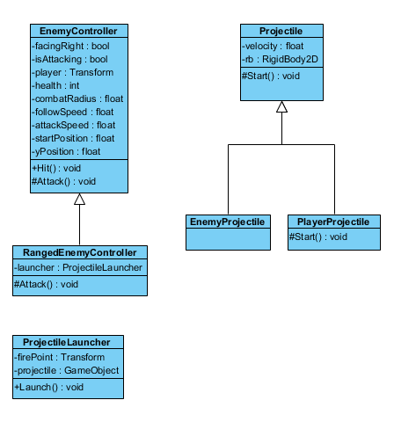

Player
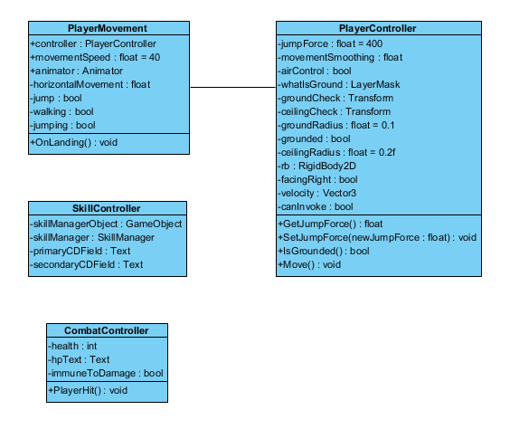

Global Managers
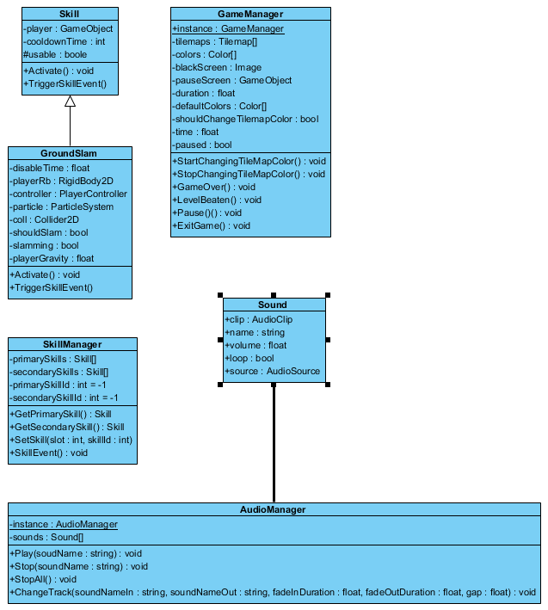

The GameManager and AudioManager both contain a variable named instance. This variable is public and static thus allowing access to them from any class or object.

The Skill class has an attribute usable which is protected to allow its deriving classes to check whether they are usable or not.

ChestInteraction
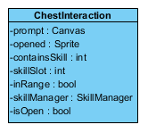

MenuController
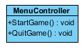

Puzzle
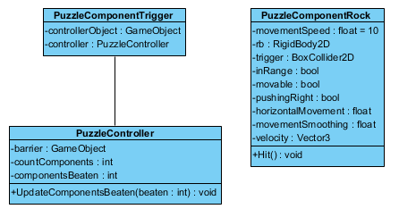

State Diagrams

AudioSource
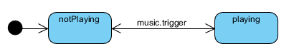

Description
Upon initialization an AudioSource is not playing a sound, it state changes when the AudioManager sends a signal to the source telling it to either start – or stop playing its sound.

SkillManager
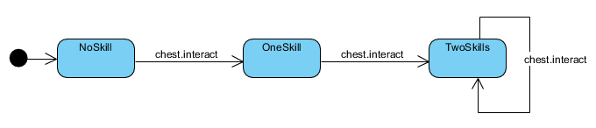

Description
Upon initialization the SkillManager has none of its skill slot attributes pointing to a valid skill. If the player opens a chest the SkillManager points to a new skill. If the SkillManager already has two valid pointers, one pointer, depending on the slot specified in the chest and skill id is overwritten.

Skills
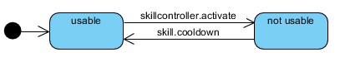

Description
Upon initialization a Skill is usable. If it is used via the SkillController the skill is put on cooldown for a set amount of time. In that time period the skill is not usable, as soon as it ends it is usable again.

Chest
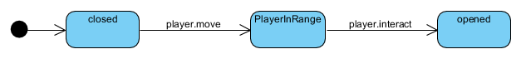

Description
Each Chest is initially closed. If the player is in range of the chest, he can interact and open the chest. Thus if a chest detects a player is in range, it changes its state and allows interaction.

PlayerController
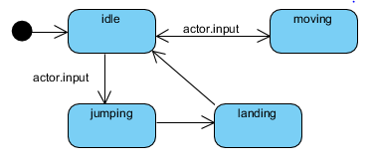

Description
By default, all variables that allow player movement are either false or “0”. As soon as an input is detected it either changes to a moving state, telling unity in which direction to move the player object. If a jump input is detected, the player controller enters a jumping state, modifying or denying further inputs. If the player object touches the ground, the PlayerController changes to a landing state, sending out notifications to event listeners telling them, that the player stopped jumping.

EnemyController
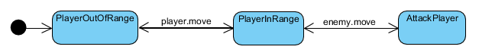

Description
Enemies are initiated in an idle state as long as the player object is out of a specified radius, the player is out of range. If the player moves into that radius the controller changes state and starts moving the enemy object towards the player, finally entering the attacking state.

PuzzleController
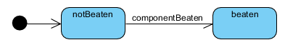

Description
Each puzzle contains of certain components. At initialization the no component is marked as beaten within the controller. Once a component is beaten, the controller changes state and depending on the puzzle allows further progress, or waits for more components to be beaten.

GameManager
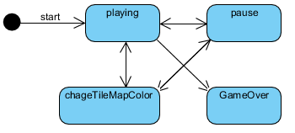

Description
Upon initialization the GameManager is in an idle state, described here as playing. If the player presses the escape key the GameManager changes into the pause state freezing the game until the player exits the pause menu. If the player triggers a certain event, the GameManager changes state to changeTileMapColor, recoloring the map in a set interval until the player reaches another trigger.
If the player dies the GameManager enters the GameOver state, in which he after freezing the game restarts the level.

